2023 Scholarship Program
for Descendants of UN Korean War veterans
(Hankuk University of Foreign Studies, Ministry of Patriots and Veterans Affairs, Korea)

1. Program Objective
The scholarship program is designed to provide higher education in Korea for descendants of UN Korean War Veterans in order to recompense the sacrifices made by those Korean War veterans of UN allied nations and to strengthen friendship with those nations.

2. Host Institutions
Hankuk University of Foreign Studies http://www.hufs.ac.kr
Hankuk University of Foreign Studies (HUFS) was established in 1954. In addition to its focus on the theory and practice of foreign languages, HUFS encourages students to use the language skills that they have acquired to study the politics, economy, society and culture of each region of the world. HUFS is a specialized university that educates students to become creative experts, international Koreans and independent researchers who will contribute to the development and exchange of culture.

Ministry of Patriots and Veterans Affairs, Korea http://www.mpva.go.kr
The Ministry of Patriots and Veterans Affairs (MPVA) functions as the bedrock of national patriotism and security by establishing and implementing policies and programs those provide compensation, educational benefits, health care, employment, and loan assistance to Patriots and Veterans.

3. Total Number of Scholarship Winners: Maximum 5 students

- Nationality Requirement
National Quota | Name of Countries (22 Countries)
1 from each of the UN allied nations | USA, Australia, United Kingdom, Canada, New Zealand, Turkey, The Netherlands, Luxemburg, Colombia, Belgium, Ethiopia, France, Greece, Philippines, South Africa, Thailand, India, Italy, Denmark, Sweden, Norway, Germany
Total | Maximum 5 persons

4. Applicable fields for Hankuk University of Foreign Studies
o Available courses: Bachelor’s Program, Master’s Program or Doctoral Program
o Available fields for Bachelor’s Program
All undergraduate majors of colleges at HUFS (except for College of Education, Law, Division of
Language & Diplomacy): http://international.hufs.ac.kr
* Please also check the admission guide on the website for the list of colleges and eligibility
o Available fields for Master’s or Doctoral Program
- Graduate School: http://builder.hufs.ac.kr/user/graeng/
- Graduate School of International & Area Studies (except for U-PEACE): http://gsias.hufs.ac.kr/
o All scholarship awardees must take 1 year of Intensive Korean language program once they arrive in Korea. The language program is offered on HUFS Global campus located in Yongin city. While taking the Korean language program, awardees will apply for their selected degree programs by mid-November, 2023.
o It is the responsibility of each awardee to meet all requirements for the HUFS degree program admission including the language proficiency, such as obtaining TOPIK(Test of Proficiency in Korean) level 3 for the Korean track majors or TOEFL IBT 80 for English track majors. Their admission to our main degree program may be rejected otherwise.

5. General Notes for 2023 Selection
o Applicants must be descendants of UN Korean War Veterans and must submit relevant documents
o National quota: Only 1 student from each country will be selected as scholarship awardee
o Exemption of Intensive Korean language program for MA or PhD candidates: TOPIK level 5 or 6 certificate holder. These students may enter the graduate school starting from September 1, 2023.

6. Duration of Scholarship
o Bachelor’s Program
a. First year student admission: 5 yrs. (Mar.6, 2023 ~ Feb.16, 2028)
1 yr. of Intensive Korean language + 4 yrs. of Bachelor’s program
b. Transfer admission: 3~4 yrs. (Mar.6, 2023 ~ Feb.16, 2026 or 2027)
1 yr. of Intensive Korean language + 2~3 yrs. of Bachelor’s program
o Master’s Program: 3 yrs. (Mar.6, 2023 ~ Feb.16, 2026)
1 yr. of Intensive Korean language + 2 yrs. of Master’s program
o Doctoral Program: 3~4 yrs. (Mar.6, 2023 ~ Feb.16, 2026 or 2027)
1 yr. of Intensive Korean language + 2~3 yrs. of Doctoral program

7. Intensive Korean Language Program
o Duration : 1 year
o Host Institution: Center for Korean Language and Culture, HUFS Global Campus in Yongin City
o After 1 year of Korean language training, students will enroll in their selected degree programs.

8. Application Qualifications
o Both the applicant and his/her parents must be citizens of a foreign country (non-Korean).
o Applicants should be in good health, both mentally and physically, to stay in Korea for a long period of time.
o Applicants must be able to live with a roommate as all the dormitories are double rooms.
o Applicants should hold a high school, Bachelor’s or Master’s diploma at least by February 1, 2023.
* For the Bachelor’s program
a. First year admission: students who hold a high school diploma after completing or successfully graduating from 12 years of formal education in or outside of Korea.
b. Transfer admission: 2-3 year college graduates or students who have completed at least 1-year of coursework at a university
* For the Master’s program: students who hold a Bachelor’s degree or a diploma that is equivalent to or higher than Bachelor’s degree.
* For the Doctoral program: students who hold a Master’s degree or a diploma that is equivalent to or higher than Master’s degree.
* Applicants who are not in possession of the requisite diploma should present the required diploma before entry.
o Bachelor’s or Master’s Program applicants should have a cumulative grade point average (G.P.A.) of at least 2.67 on a 4.0 scale, 2.87 on a 4. 3 scale, 3.0 on a 4.5 scale.
o Doctoral Program applicants should have a cumulative grade point average (G.P.A.) of at least 3.11 on a 4.0 scale, 3.34 on a 4. 3 scale, 3.5 on a 4.5 scale.
* Students will be selected on the basis of their academic merits preferentially.

9. Scholarship Benefits
o Scholarship Period: same as the period of invitation
o Scholarship Benefits include:
- Intensive Korean Language Program Fee: The full tuition fee will be paid by HUFS
- Degree Program Tuition: The admission fee and tuition fees will be paid by HUFS
※ Students should get a cumulative grade point average (G.P.A) of at least 3.0 on a 4.5 scale after they start their degree program at HUFS to receive their tuition scholarship.
- Housing: On-campus housing will be provided by HUFS to the scholarship recipient
- Monthly Allowance: 500,000 KRW will be given to students from the Ministry of Patriots and Veterans Affairs (MPVA), Korea
※ Scholarship amount is subject to change or may vary on yearly basis. The monthly allowance may not be sufficient to cover all living expenses in Korea. The Awardees are responsible for any other living expenses exceeding the monthly allowance, such as travel costs to and from Korea, costs related to COVID-19 including self-quarantine arrangement, and the Korea National Health Insurance fee.

10. Application & Selection Procedures
- Application Submission Deadline: November 18, 2022
※ Please send in the original documents of your application by postal mail
Office of International Admissions & Management
Centennial Building #204
Hankuk University of Foreign Studies (Global Campus)
81 Oedae-ro, Mohyeon-myeon, Cheoin-gu, Yongin-si,
Gyeonggi-do 17035, South Korea

- HUFS Selection committee evaluation: December 1, 2022 ~ December 20, 2022
- Announcement of Final Scholarship winners: December 23, 2022
- Entry to Korea : February, 2023
- Awardees must abide by the Korean Immigration Law and make an arrangement for the PCR test and/or self-quarantine, if necessary. All related expenses are responsible by each awardee.
- Korean language course: starting from March 6, 2023

11. Contact & Mailing Information for HUFS
Korean War Scholarship Program Manager
- Tel: 82-31-330-4735
- Email: hufsinbound@hufs.ac.kr
- Website: http://international.hufs.ac.kr

12. Selection Criterion
o All documents including the transcript, self introduction, study plan, language proficiency (Korean or English), letter of recommendation, research papers and awards will be reviewed by the HUFS Selection committee.

13. Required Documentation (o – mandatory submission, △ – optional submission)
Check List for Application Documents | BA | MA | Ph.D
1. Application form (Attachment #1) | o | o | o
2. Self Introduction | o | o | o
3. Study Plan | o | o | o
4. A Letter of Recommendation | o | o | o
5. Certificates(s) of graduation from previously attended Institution(s)  -BA: Certificate(s) of graduation from middle school, and high school (or a certificate which presents the completion of 12 year formal education)  -MA: Certificate of graduation from Bachelor’s degree  -Doctoral: Certificate of graduation from Master’s degree | o | o | o
6. Official transcript of previously attended institution(s)  -BA: Official transcript of middle school, and high school  -MA: Official transcript of Bachelor’s degree  -Doctoral: Official transcript of Master’s degree | o | o | o
7. Certificate of current enrollment at a university or certificate of graduation from a college (For BA transfer) | o | - | -
8. Certificate of TOPIK score (original copy), if available | △ | △ | △
9. Certificate of TOEFL or IELTS score (original copy), if available | △ | △ | △
10. Published research papers or thesis, if available (one or two) | - | △ | △
11. Awards, if available (one or two) | △ | △ | △
12. Copy of passport (information page) | o | o | o
14. 13. Certificate of Citizenship of his/her Parents: birth certificate, passport, etc. | o | o | o
14. Official certificate of veteran’s service in the Korean War from whom he/she is claiming relationship | o | o | o
15. Official certificate of direct descent from Korean War veteran (son, daughter or grandchild)  *Can be replaced with PEACE Camp participation certificate given by MPVA. | o | o | o
16. Health Examination Form for International Students  *Must submit a completed health form signed by a doctor. | o | o | o

o Note
- Documents should be presented in the original form. Documents not written in English or Korean must be accompanied by a complete and accurate English or Korean translation certified by the issuing institution.
- Submitted documents will not be returned to the candidates.
- Incomplete or inaccurate documents are subject to rejection by HUFS & MPVA. (Even after entry to Korea)
- In case of submitting copies or translated copies of original documents (e.g. diploma), applicants must submit the original to the Korean Embassy (Consulate) to have the copy notarized or to the Apostille office in their home country to be certified as a bona fide copy of the original.
- Applicants who do not hold a diploma may submit a certificate or letter of anticipated graduation.

Check List for Application Documents

- Name of Applicant: (given name) (family name)
- Country:
3) Desired Degree Program: □ Bachelor’s □ Bachelor’s Transfer □ Master’s □ Doctoral

(*Please tick(√) in the appropriate box.)
Application Documents | Submission(Y/N)
Check List | Yes | No
1. Application form (Attachment #1)
2. Self Introduction
3. Study Plan
4. A Letter of Recommendation
5. Certificates(s) of graduation from previously attended Institution(s)
6. Official transcript of previously attended institution(s)
7. Certificate of current enrollment at a university or certificate of graduation from
a college (For BA transfer)
8. Certificate of TOPIK score (original copy), if available
9. Certificate of TOEFL or IELTS score (original copy), if available
10. Published research papers or thesis, if available (one or two)
11. Copy of Awards, if available (one or two)
12. Copy of passport (information page)
14. 13. Certificate of Citizenship of his/her Parents: birth certificate, passport, etc.
14. Official certificate of veteran’s service in the Korean War from whom he or she is claiming relationship
15. Official certificate of direct descent from Korean War veteran (son, daughter or grandchild)
16. Health Examination Form for International Students
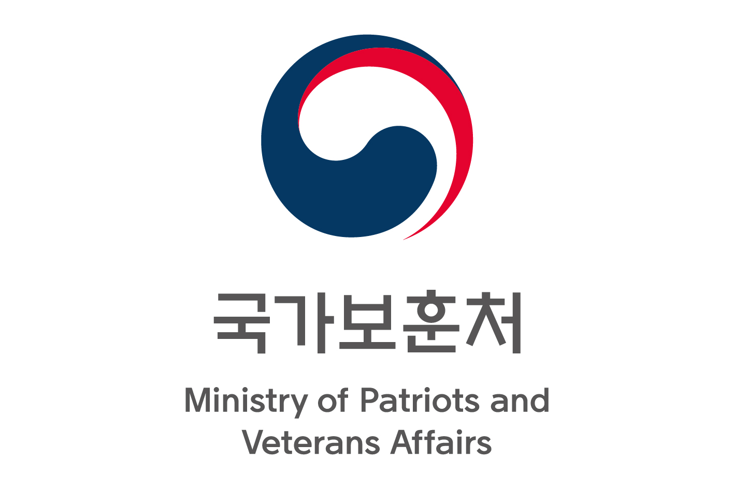
Attachment #1
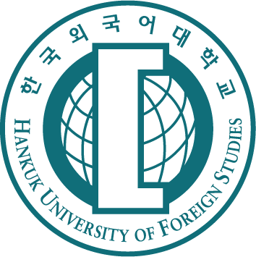 | 2023 Scholarship Program for Descendants of  UN Korean War Veterans  Hankuk University of Foreign Studies  Ministry of Patriots and Veterans Affairs, Korea

※ Please fill in all relevant sections of the application form and write clearly
Please indicate your desired degree program:

Undergraduate Study --------------------------------------------------------------------------------------------------------
Undergraduate Study(transfer) ---------------------------------------------------------------------------------------------
Master’s Study -------------------------------------------------------------------------------------------------------
Doctoral Study ------------------------------------------------------------------------------------------------------

`
Personal Information

Family Name:_________________________ First Name:_________________________  Sex (Male/Female):________________  Date of Birth (dd/mm/yy):________/________/_______  Country of Birth:____________________ Nationality:__________________________  Passport  Number:______________ Date of Issue: ____/____/_____ Date of Expiry: ____/____/_____  First Language:____________________  Email: ___________________@______________________ (please write clearly) | Attach  your photo  here  (3 * 4 cm)
Address:
__________________________________________________________________________________________________
____________________________________ Country:_____________________ Postal Codes:________________
Telephone:___________________________________

`
Korean War Veteran’s Information

* Korean War veteran from whom you are claiming relationship
Full Name:_____________________________________________ Date of Birth (dd/mm/yy): ____/____/_____
Period of service in the Korean War (dd/mm/yy): From ______/______/________ to ______/______/________
Nationality:________________________________
Name of Troop: ________________________________ Rank or Position: ________________________________
* Your relationship with him or her (Please tick where appropriate)
Son Daughter Grandson Granddaughter
`
Educational Background

* Information of your final education
Name of institution:___________________________________________________________
City: __________________________ Country: ___________________________________
Major, if available: ______________________________
Cumulative GPA:_____________ out of _________________ / Check if not available
Date of graduation or anticipated graduation (dd/mm/yy):______/______/________
Degree Level: High school Bachelor Master
Title of graduation dissertation, if available:_______________________________________________________________
Published papers, if available: __________________________________________________________________________
Published papers, if available: __________________________________________________________________________
Awards, if available: _________________________________________________________________________________
Awards, if available: _________________________________________________________________________________
* Academic Careers
Name of school | Period (years) | Country | Major | Diploma or Degree
 | - ( )
 | - ( )
 | - ( )
 | - ( )
※ Bachelor’s program applications: Elementary, Middle & High school
Master’s program applications: High school & University(undergraduate)
Doctoral program applications: University(undergraduate & Master’s)

`
Desired Major at HUFS

* Campus: Seoul Yongin(Gyeonggido)
* Name of College or graduate school at HUFS:_______________________________________________________________
* Majors
- 1st Choice:__________________________________________________________________
- 2nd Choice:__________________________________________________________________
- 3rd Choice:__________________________________________________________________

`
Language Proficiency

* English: TOEFL __________________ IELTS ____________________
* Korean: TOPIK __________________
* Please estimate your level of Korean if you do not have an official TOPIK score: Beginner Intermediate Advanced
* Admission requirement for HUFS undergraduate / graduate studies is as follows:
For Korean Track Major: TOPIK 3 / For English Track Major: TOEFL 80
* You must present a valid language certificate by Nov 15, 2023 or your admission to HUFS degree program will be rejected.

`
Occupation and Research Career

Name of company or institution | Country | Period | Position | Duty
 |  | -
 |  | -
 |  | -

`
Health Statement

Do you have serious health problems or require disability support? YES NO
If YES, please specify : __________________________________________________________________________
________________________________________________________________________________________________
________________________________________________________________________________________________

`
Scholarship Statement

Have you received any scholarship from HUFS or the Korean government before? YES NO
If YES, please specify : __________________________________________________________________________
________________________________________________________________________________________________
________________________________________________________________________________________________

I hereby declare that the information given in this application is accurate and complete.

Name ____________________________ Signature __________________________ Date ___________________________

We will not process incomplete application forms. Please make sure that you have completed all relevant sections of this application form and provided all required attachments.

§ Please submit completed application form & all required supporting documents by postal mail to:
Office of International Admissions & Management
Centennial Building #204
Hankuk University of Foreign Studies (Global Campus)
81 Oedae-ro, Mohyeon-myeon, Cheoin-gu, Yongin-si,
Gyeonggi-do 17035, South Korea
- Telephone : 82-31-330-4735 (Yong-in) - Email : hufsinbound@hufs.ac.kr
- Websites http://international.hufs.ac.kr / http://www.hufs.ac.kr / http://www.facebook.com/hufskorea

Attachment #2

Health Examination Form for International Students
Hankuk University of Foreign Studies

I. Personal Information
Family Name(姓):__________________________ First Name(名):_________________________
Date of Birth(dd/mm/yy):________/________/_______ Gender: Male( ) Female ( )
Nationality:__________________________

II. Personal Medical Assessment
1. Have you had any serious illness or injury that required hospitalization in the last two years?  2. Have you ever made repeated visits to a doctor for an illness or injury?  3. Have you ever had any of the followings?  - Hepatitis or tuberculosis?  - close contact with any infectious disease?  - COVID-19  4. Do you have any allergies?  5. Have you ever cared for by a mental clinician? | Yes ( ) No ( )  Yes ( ) No ( )  Yes ( ) No ( )  Yes ( ) No ( )  Yes ( ) No ( )  Yes ( ) No ( )  Yes ( ) No ( )
If the answer to any of above questions is Yes, please provide the question number and specify in details below

Question Number( )
(Describe)
I hereby state that information submitted on this form is true

Student Signature___________________________________ Date_________________________________

III. Health Examination Report (to be completed in English by a clinician and done within 6 months before you arrive in Korea)

1. Hepatitis Type B
Results: | HBsAg | Positive | Negative
 | HBsAb or Anti-HBs | Positive | Negative
 | HBcAB or Anti-HBc | Positive | Negative
No Active or prior infection ( ) Immune ( ) New infection or chronic carrier ( ) Unclear ( )

______________________________________________________________________ Date of exam:___________________
(Describe)
2. Chest X-Ray for Tuberculosis Test

Date:__________________ Normal Abnormal ______________________________________________________
(Describe)

□ Clinician’s Signature (if available, please provide the clinic’s stamp on top of the date)

__________________________________________________________________________________________________________
MD/NP/PA Name (Please Print) Signature Date

_________________________________________________________________________________________________________
Address Country Telephone Number

